Chapter 12: Significance Tests in Practice

Objectives: Students will:
Conduct one-sample and paired data t significance tests.
Explain the differences between the one-sample confidence interval for a population proportion and the one-sample significance test for a population proportion.
Conduct a significance test for a population proportion.

AP Outline Fit:
IV. Statistical Inference: Estimating population parameters and testing hypotheses (30%–40%)
B. Tests of significance
2. Large sample test for a proportion
4. Test for a mean
5. Test for a difference between two means (paired)

What you will learn:

- One-Sample t Test for µ (σ unknown)
  - Carry out a t test for the hypothesis that a population mean µ has a specified value against either a one-sided or a two-sided alternative. Use Table C of t critical values to approximate the P-value or carry out a fixed α test.
  - Recognize when the t procedures are appropriate in practice, in particular that they are quite robust against lack of Normality but are influenced by skewness and outliers.
  - Also recognize when the design of the study, outliers, or a small sample from a skewed distribution make the t procedures risky.
  - Recognize paired data and use the t procedures to perform significance tests for such data.
- Inference about One Proportion
  - Use the z statistic to carry out a test of significance for the hypothesis about a population proportion p against either a one-sided or a two-sided alternative.
  - Check that you can safely use the one-proportion z test in a particular setting.

Section 12.1: Tests about a Population Mean

Knowledge Objectives: Students will:
Define the one-sample t statistic.

Construction Objectives: Students will be able to:
Determine critical values of t (t*), from a “t table” given the probability of being to the right of t*.
Determine the P-value of a t statistic for both a one- and two-sided significance test.
Conduct a one-sample t significance test for a population mean using the Inference Toolbox.
Conduct a paired t test for the difference between two population means.

Vocabulary:
Statistics –

Key Concepts:

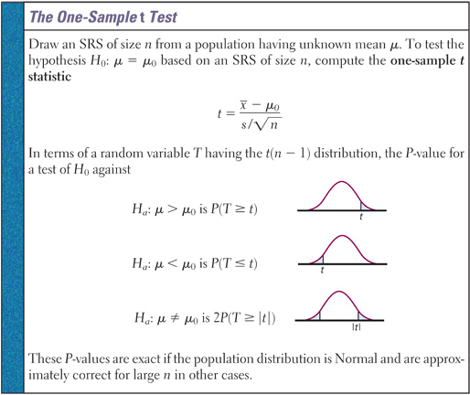

Example 1: Diet colas use artificial sweeteners to avoid sugar. These sweeteners gradually lose their sweetness over time. Trained tasters sip the cola along with drinks of standard sweetness and score the cola on a “sweetness scale” of 1 to 10. The data below is the difference after 4 months of storage in the taster’s scores. The bigger these differences, the bigger the loss of sweetness while in storage. Negative values are “gains” in sweetness.
2.0 0.4 0.7 2.0 -0.4 2.2 -1.3 1.2 1.1 2.3
Are these data good evidence that the cola lost sweetness in storage?

- Step 1: Hypothesis
H₀:
H_{a}:
- Step 2: Conditions
SRS:
Normality:
Independence:
- Step 3: Calculations
Test Statistic:
- Step 4: Interpretation

Example 2: A simple random sample of 12 cell phone bills finds x-bar = $65.014 and s= $18.49. The mean in 2004 was $50.64. Test if the average bill is different today at the α = 0.05 level.

- Step 1: Hypothesis
H₀:
H_{a}:
- Step 2: Conditions
SRS:
Normality:
Independence:
- Step 3: Calculations
Test Statistic:
- Step 4: Interpretation

Example 3: A simple random sample of 40 stay-at-home women finds they watch TV an average of 16.8 hours/week with s = 4.7 hours/week. The mean in 2004 was 18.1 hours/week. Test if the average is different today at α = 0.05 level.

- Step 1: Hypothesis
H₀:
H_{a}:
- Step 2: Conditions
SRS:
Normality:
Independence:
- Step 3: Calculations
Test Statistic:
- Step 4: Interpretation

Example 4: To test if pleasant odors improve student performance on tests, 21 subjects worked a paper-and-pencil maze while wearing a mask. The mask was either unscented or carried a floral scent. The response variable is their average time on three trials. Each subject worked the maze with both masks, in a random order (since they tended to improve their times as they worked a maze repeatedly). Assess whether the floral scent significantly improved performance.

Subject | Unscented | Scented |  | Subject | Unscented | Scented
1 | 30.60 | 37.97 |  | 12 | 58.93 | 83.50
2 | 48.43 | 51.57 |  | 13 | 54.47 | 38.30
3 | 60.77 | 56.67 |  | 14 | 43.53 | 51.37
4 | 36.07 | 40.47 |  | 15 | 37.93 | 29.33
5 | 68.47 | 49.00 |  | 16 | 43.50 | 54.27
6 | 32.43 | 43.23 |  | 17 | 87.70 | 62.73
7 | 43.70 | 44.57 |  | 18 | 53.53 | 58.00
8 | 37.10 | 28.40 |  | 19 | 64.30 | 52.40
9 | 31.17 | 28.23 |  | 20 | 47.37 | 53.63
10 | 51.23 | 68.47 |  | 21 | 53.67 | 47.00
11 | 65.40 | 51.10

- Step 1: Hypothesis
H₀:
H_{a}:

- Step 2: Conditions
SRS:
Normality:
Independence:

- Step 3: Calculations
Test Statistic:
- Step 4: Interpretation

Homework:
Day 1: pg 746 12.1, 12.2, 12.4; pg 754 12.5, 12.6
Day 2: pg 760 12.9, 12.10, 12.12; pg 762 12.15, 12.18, 12.21
Section 12.2: Tests about a Population Proportion

Knowledge Objectives: Students will:
Explain why p₀, rather than , is used when computing the standard error of in a significance test for a population proportion.
Explain why the correspondence between a two-tailed significance test and a confidence interval for a population proportion is not as exact as when testing for a population mean.
Explain why the test for a population proportion is sometimes called a large sample test.
Discuss how significance tests and confidence intervals can be used together to help draw conclusions about a population proportion.

Construction Objectives: Students will be able to:
Conduct a significance test for a population proportion using the Inference Toolbox.

Vocabulary: none new

Key Concepts:

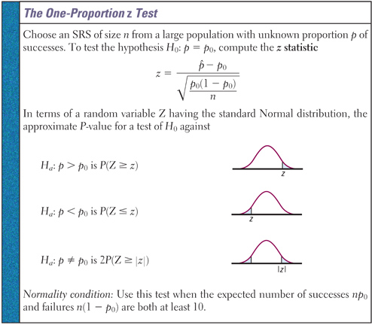

Example 1: According to OSHA, job stress poses a major threat to the health of workers. A national survey of restaurant employees found that 75% said that work stress had a negative impact on their personal lives. A random sample of 100 employees form a large restaurant chain finds 68 answered “Yes” to the work stress question. Does this offer evidence that this company’s employees are different from the national average?

- Step 1: Hypothesis
H₀:
H_{a}:

- Step 2: Conditions
SRS:
Normality:
Independence:

- Step 3: Calculations
Test Statistic:

- Step 4: Interpretation

Example 2: Nexium is a drug that can be used to reduce the acid produced by the body and heal damage to the esophagus due to acid reflux. Suppose the manufacturer of Nexium claims that more than 94% of patients taking Nexium are healed within 8 weeks. In clinical trials, 213 of 224 patients suffering from acid reflux disease were healed after 8 weeks. Test the manufacturers claim at the α=0.01 level of significance.

- Step 1: Hypothesis
H₀:
H_{a}:

- Step 2: Conditions
SRS:
Normality:
Independence:

- Step 3: Calculations
Test Statistic:
- Step 4: Interpretation

Example 3: According to USDA, 48.9% of males between 20 and 39 years of age consume the minimum daily requirement of calcium. After an aggressive “Got Milk” campaign, the USDA conducts a survey of 35 randomly selected males between 20 and 39 and found that 21 of them consume the min daily requirement of calcium. At the α = 0.1 level of significance, is there evidence to conclude that the percentage consuming the min daily requirement has increased?

- Step 1: Hypothesis
H₀:
H_{a}:

- Step 2: Conditions
SRS:
Normality:
Independence:

- Step 3: Calculations
Test Statistic:

- Step 4: Interpretation

Homework: pg 771: 12.23 to 12.27
Chapter 12: Review

Objectives: Students will be able to:
Summarize the chapter
Define the vocabulary used
Know and be able to discuss all sectional knowledge objectives
Complete all sectional construction objectives
Successfully answer any of the review exercises

Conduct one-sample and paired data t significance tests.
Explain the differences between the one-sample confidence interval for a population proportion and the one-sample significance test for a population proportion.
Conduct a significance test for a population proportion.

Vocabulary: None new

TI-83 Calculator Help:
t-Test:
- Press STAT
  - Tab over to TESTS
  - Select T-Test and ENTER
    - Highlight Stats or if Data (id the list its in)
    - Entry μ₀, x-bar, st-dev, and n from summary stats
    - Highlight test type (two-sided, left, or right)
    - Highlight Calculate and ENTER
Read t-critical and p-value off screen

t-Confidence Interval:
- Press STAT
  - Tab over to TESTS
  - Select Z-Interval and ENTER
    - Highlight Stats
    - Entry s, x-bar, and n from summary stats
    - Entry your confidence level (1- α)
    - Highlight Calculate and ENTER
- Read confidence interval off of screen
  - If μ₀ is in the interval, then FTR
  - If μ₀ is outside the interval, then REJ

One-Sample Proportion Test
- Press STAT
  - Tab over to TESTS
  - Select 1-PropZTest and ENTER
    - Entry p₀, x, and n from given data
    - Highlight test type (two-sided, left, or right)
    - Highlight Calculate and ENTER
- Read z-critical and p-value off screen

Homework: pg775 – 77; 12.31 to 12.38

